A000-Ghana-Ashante-Akan-Ancestoral Bust —20th Century   
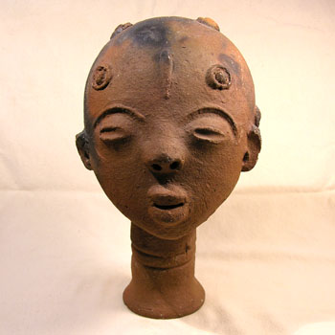  
Fine Akan terracotta ancestral head. These well executed heads served as stylized funerary portraits and memorials for the Akan peoples of Ghana. In excellent condition with only minor chips missing from the ears. Reddish clay with some darker areas known as "fire clouding", a result of uneven temperatures in the wood-fired kilns. Displays beautifully.   
  
9" tall x 5.5" across   
  
$175